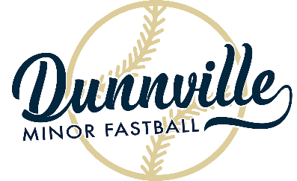

Dunnville Minor Fastball
TYKE Schedule 2023

Team | Coaches | Pictures
CANADIAN TIRE | BRANDON OTTAWAY CAITLYN OTTAWAY | JUNE 12 – 5:15 pm
VIC POWELL | VICTORIA PATTEMORE MELISSA UYEN | JUNE 12 – 5:30 pm
LEGION | DAVE ENGELAGE AARON BOWN SCOTT HOUSER | JUNE 12 – 5:45 pm
PENN FINANCIAL | BRIAN MILLER | JUNE 12 – 6:00 pm

All games start at 6:30 pm at Kinsmen Park. Diamond #1 is closest to the road. Diamond #3 is closest to the canteen.

DATE | DIAMOND | HOME | VISITOR
JULY 10 | 3 | 4 | 1
JULY 17 | 1 | 1 | 2
JULY 17 | 3 | 3 | 4
JULY 24 | 1 | 2 | 3
JULY 24 | 3 | 4 | 1
JULY 31 | 1 | 2 | 4
JULY 31 | 3 | 1 | 3
DATE | DIAMOND | HOME | VISITOR
MAY 23 | 2 | 1 | 2
MAY 23 | 3 | 3 | 4
MAY 29 | 1 | 2 | 3
MAY 29 | 3 | 4 | 1
JUNE 5 | 1 | 2 | 4
JUNE 5 | 3 | 1 | 3
JUNE 12 | 1 | 3 | 2
JUNE 12 | 3 | 4 | 1
JUNE 19 | 1 | 1 | 2
JUNE 19 | 3 | 3 | 4
JUNE 26 | 1 | 2 | 3
JUNE 26 | 3 | 4 | 1
JULY 3 | 1 | 2 | 4
JULY 3 | 3 | 1 | 3
JULY 10 | 1 | 3 | 2
4

Year End Play-offs: August 7- August 10
Skills Night (for all teams): Friday, August 11
Year End Tournament: Saturday, August 12 & Sunday, August 13
HOME TEAM PUTS AWAY BASES IN THEIR PROPER PLACE IN THE EQUIPMENT ROOM. THEY ALSO REPLACE THE BASE PLUGS AND COVER THEM UP
BROCK UNIVERSITY COACH HUGH HANLY WILL COME TO YOUR PRACTICE TO TEACH SKILLS
UPON REQUEST

